**MACHINE LEARNING MODEL DEPLOYMENT WITH IBM CLOUD WATSON STUDIO**

**MACHINE LEARNING BLOCK DIAGRAM:**

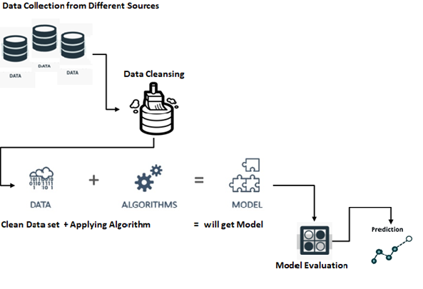

**Project Title**: Optimizing Machine Learning Model Performance with Ensemble Methods and Hyperparameter Tuning.

**Project Overview:**

Machine learning models play a crucial role in various domains, from finance to healthcare and beyond. However, achieving optimal model performance requires more than just selecting the right algorithm. This project aims to demonstrate the importance of ensemble methods and hyperparameter tuning in enhancing the performance of a machine learning model.

**Project Objectives**

Data Collection and Preprocessing:

Collect a relevant dataset suitable for a machine learning task.Perform data preprocessing, including handling missing values, encoding categorical variables, and scaling numerical features.

Baseline Model:

* Train a baseline machine learning model (e.g., a decision tree or logistic regression) using default hyperparameters.
* Evaluate its performance using appropriate metrics (e.g., accuracy, F1-score, ROC-AUC).

Ensemble Methods:

* Implement ensemble methods such as Random Forest, Gradient Boosting, and Voting Classifier.
* Train and evaluate these ensemble models and compare their performance against the baseline model.

Hyperparameter Tuning:

* Perform hyperparameter tuning for the ensemble methods to find the best combination of hyperparameters.
* Utilize techniques like grid search or randomized search to explore the hyperparameter space efficiently.

Model Evaluation:

* Compare the performance of the tuned ensemble models against the baseline model.
* Use appropriate evaluation metrics to assess improvements in accuracy, precision, recall, and other relevant criteria.

Model Interpretability:

* Explore techniques for model interpretability, such as feature importance analysis or SHAP Values.
* Gain insights into how the ensemble models make predictions.

Documentation and Reporting:

* Create a comprehensive report summarizing the project’s methodology, findings, and Recommendations.
* Visualize the results using plots and charts to make them more understandable.
* Discuss the impact of ensemble methods and hyperparameter tuning on model Performance.

**Benefits:**

* Gain hands-on experience in implementing ensemble methods and hyperparameter tuning Techniques.
* Improve your understanding of how different algorithms and hyperparameters impact model Performance.
* Showcase the importance of model optimization for real-world applications.

**Challenges:**

* Selecting an appropriate dataset and defining a clear machine learning task.
* Balancing the trade-off between model complexity and overfitting during hyperparameter Tuning.
* Interpreting complex ensemble models and conveying their insights effectively.

**Conclusion:**

This project will provide valuable insights into the significance of ensemble methods and Hyperparameter tuning in optimizing machine learning models. By following the outline Steps and experimenting with different techniques, you’ll gain practical skills that can be Applied to a wide range of data science and machine learning projects.